**Realizar la instalación y puesta en marcha de un servidor web Apache, con soporte para bases de datos MySQL y lenguaje del lado del servidor PHP.**

**Para entregar esta tarea es necesario entregar las capturas de imagen de los principales pasos realizados, explicando en una o dos líneas las decisiones tomadas. Es necesaria una captura final que muestre que el servicio está en funcionamiento.**

The installations will be done in a Virtual Machine. The Operative System of the virtual machine is Ubuntu 16.04 LTS 64 Bits.

**The installed components and versions are**:

- *Apache/2.4.18 (Ubuntu)*

- *MySQL Server 5.7.16-0ubuntu0.16.04.1*

- *PHP Version 7.0.8-0ubuntu0.16.04.3*

- *phpmyadmin ﻿4.5.4.1deb2ubuntu2 (all languages)*

**1.- Apache installation**

We can install Apache easily using Ubuntu's package manager, apt. A package manager allows us to install most software pain-free from a repository maintained by Ubuntu.

For our purposes, we can get started by typing these commands**:**

***$sudo apt-get update***

***$sudo apt-get install apache2***

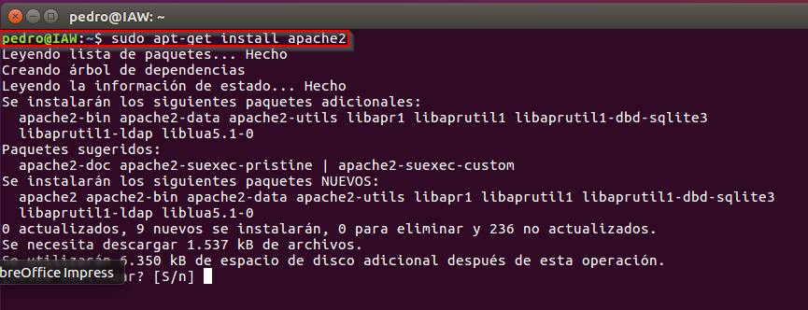

*Since we are using a* ***sudo command****, these operations get executed with root privileges. We will ask the password for the administrator password.*

*Once we've entered our password, apt will tell us which packages it plans to install and how much extra disk space they'll take up. Press "****S****" and hit Enter to continue, and the installation will proceed.*

Now We go to the navigator and put the "localhost" in the bar of navigation to check that the installation was successful:

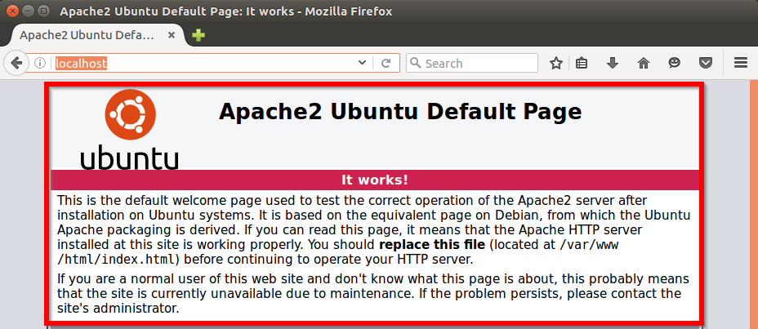

Directory where the apache configuration file is located:

*/etc/apache2*

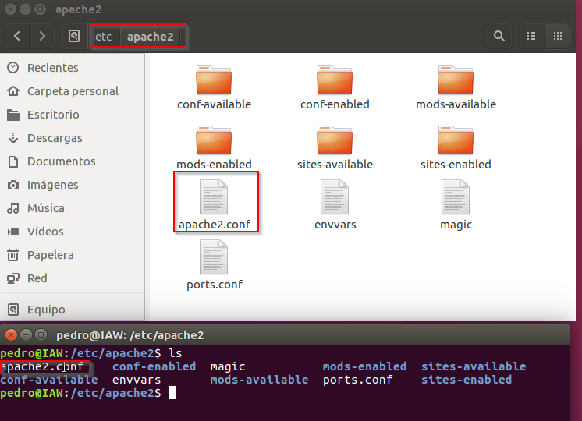

In the "***/ var / www/html"*** directory is where the files that the web server displays are stored. The website is saved here.

This is the default file that the web server shows us to prove its good operation .

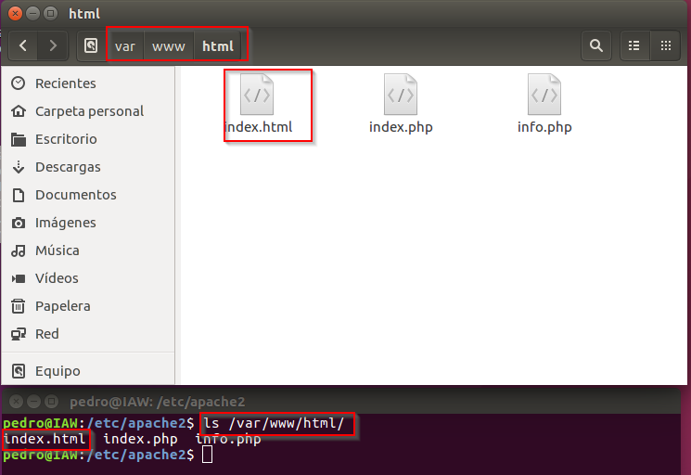

**2.- MySQL installation**

Now that we have our web server up and running, it is time to install MySQL. MySQL is a database management system. Basically, it will organize and provide access to databases where our site can store information.

Again, we can use apt to acquire and install our software. This time, we'll also install some other "helper" packages that will assist us in getting our components to communicate with each other:

***$ sudo apt-get install mysql-server mysql-common mysql-client***

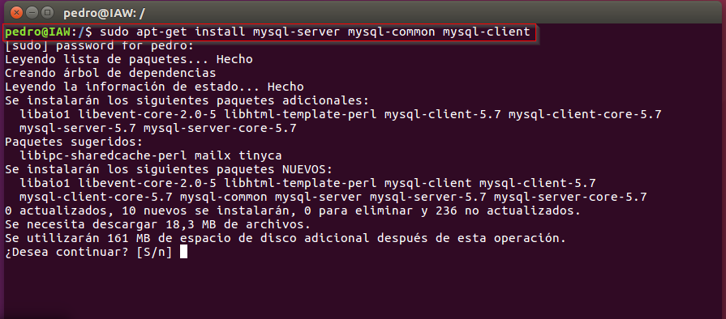

*Again, we will be shown a list of the packages that will be installed, along with the amount of disk space they'll take up. Enter "****S****" to continue.*

*During the installation, our server will ask us to select and confirm a password for the MySQL "root" user.*

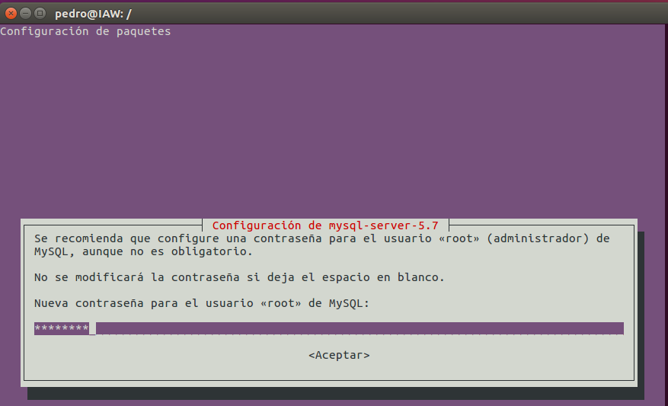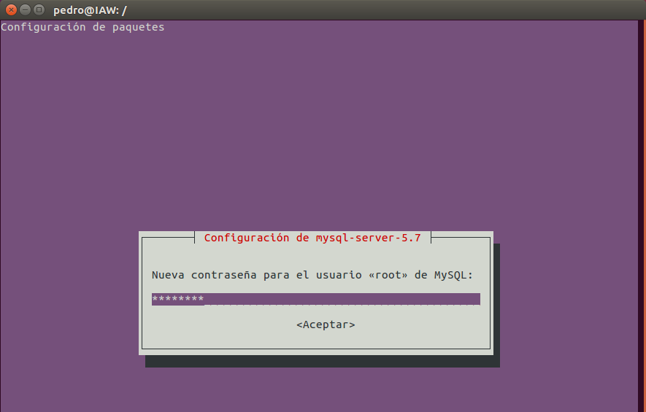

Now we go to check that MySQL is online. For this we open a terminal and put the following:

***$sudo service mysql status***

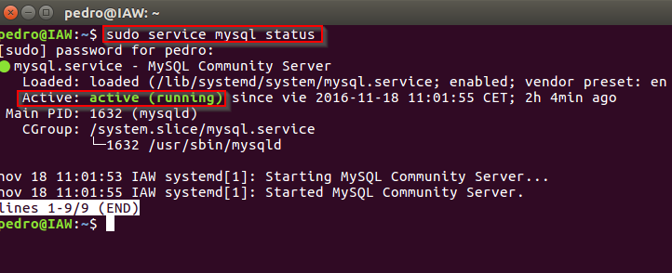

For to enter console mysql:

***$ mysql -u root -p***

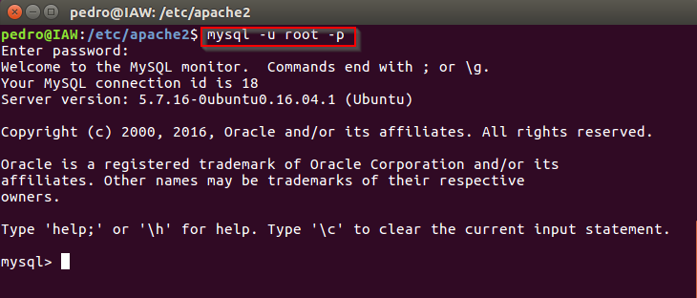

**3.- PHP installation**

PHP is the component of our setup that will process code to display dynamic content. It can run scripts, connect to our **MySQL** databases to get information, and hand the processed content over to our web server to display.

We can once again leverage the apt system to install our components.

We open a terminal and put the next:

***$ sudo apt-get install php libapache2-mod-php php-mcrypt php-mysql***

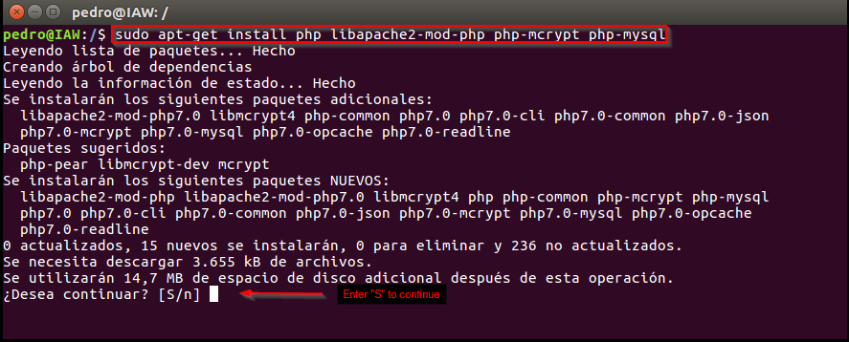

We will want to modify the way that Apache serves files when a directory is requested. Currently, if a user requests a directory from the server, Apache will first look for a file called index.html. We want to tell our web server to prefer PHP files, so we'll make Apache look for an index.php file first.

To do this, type this command to open the **dir.conf** file in a text editor with root privileges:

***$ udo nano /etc/apache2/mods-enabled/dir.conf***

It will look like this:

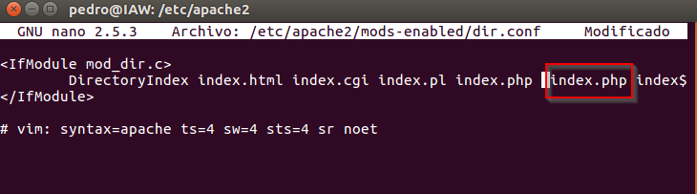

We want to move the PHP index file highlighted above to the first position after the **DirectoryIndex** specification, like this:

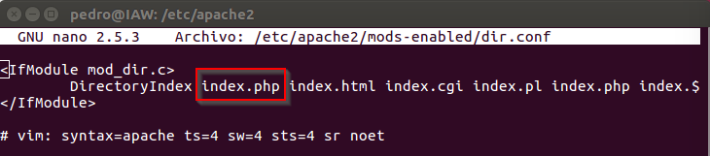

*Save the changes and exit…*

After this, we need restart the Apache web server in order for our changes to be recognized. For it we open a terminal and put the following:

***$ sudo systemctl restart apache2***

Now we check that the server is on:

***$ sudo systemctl status apache2***

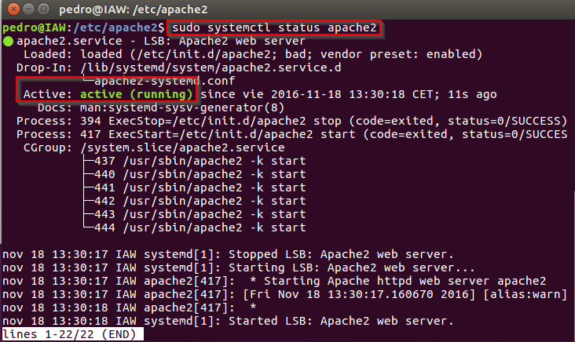

In the following directory we can to see the configuration file PHP:

***etc/php/7.0/apache2***

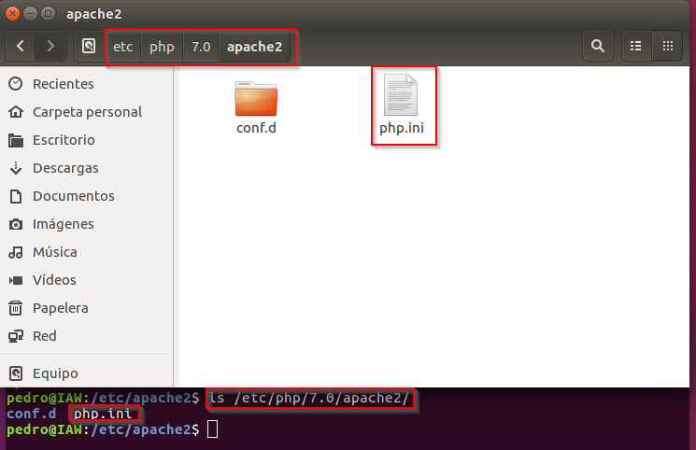

In order to test that our system is configured properly for PHP, we can create a very basic PHP script.

We will call this script index.php. In order for Apache to find the file and serve it correctly, it must be saved to a very specific directory, which is called the "**web root**".

This directory is located at **/var/www/html/**. We can create the file at that location by typing:

***$ sudo nano /var/www/html/index.php***

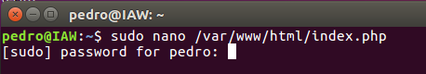

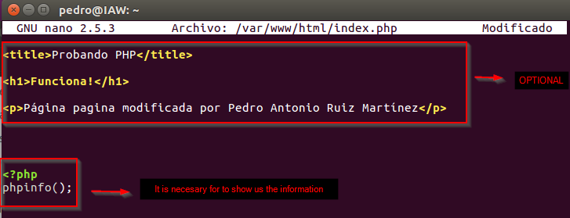

When we are finished, we save and close the file.

Now we can test whether our web server can correctly display content generated by a PHP script. To try this out, we just have to visit this page in our web browser: 127.0.0.1 or localhost.

***http://your_server_IP_address/index.php***

With  ***"*localhost"**:

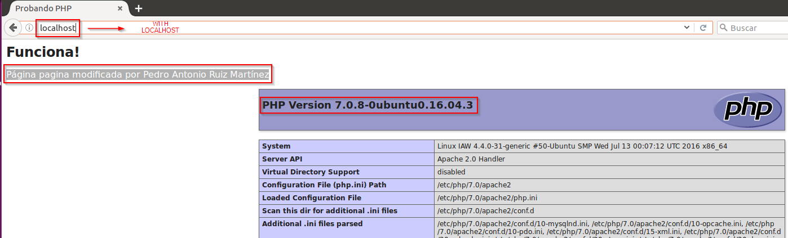

With "**127.0.0.1**":

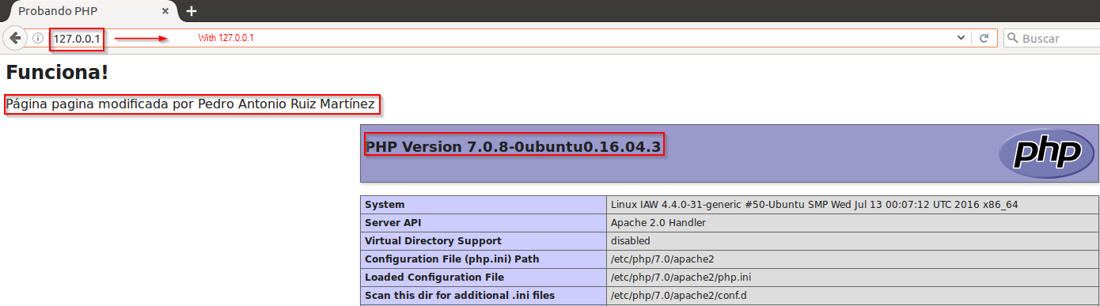

With "**IP Address**":

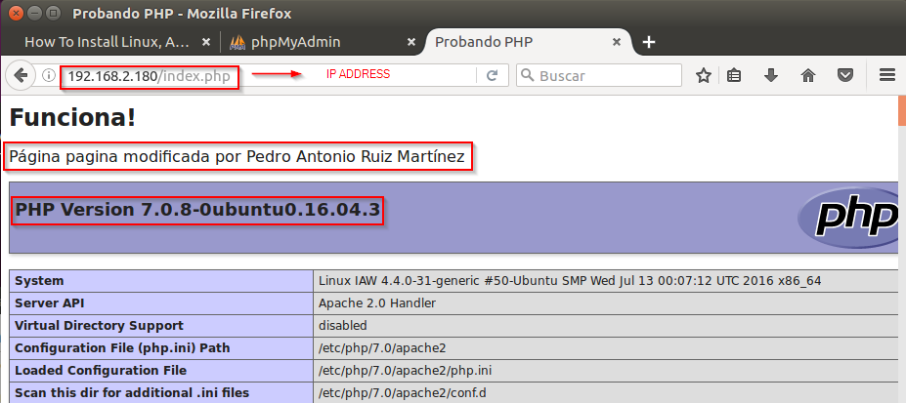

**4.- phpMyAdmin installation**

For the installation "**phpMyAdmin**" we must open the terminal and put the following sentence:

***$ sudo apt-get install phpmyadmin apache2-utils***

*During the installation, phpMyAdmin will walk us through a basic configuration. Once the process starts up, we will follow these steps:*

1. *Select Apache2 for the server*
2. *Choose* ***<No>*** *when asked about whether to Configure the database for phpmyadmin with dbconfig-common*

**1.**

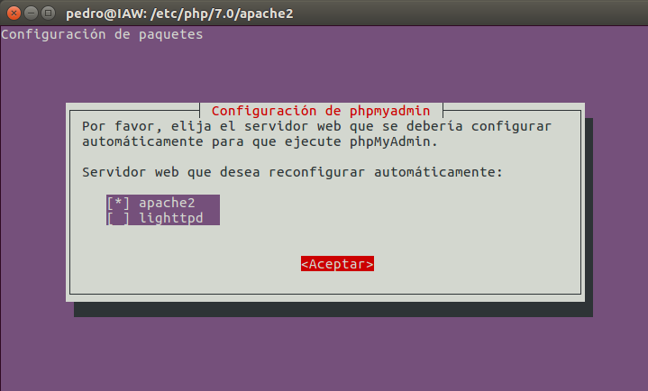

**2.**

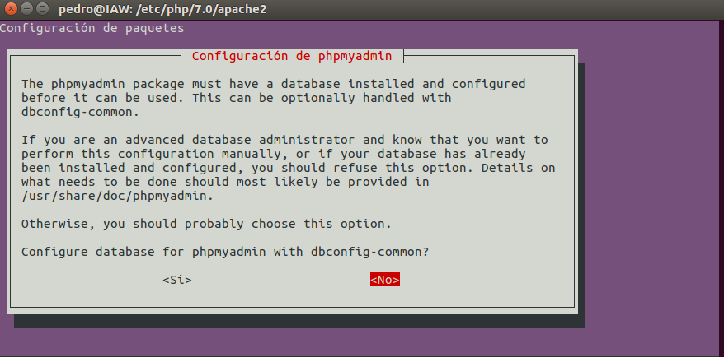

After the installation has completed, We go to the navigator and put the "localhost/phpMyAdmin" in the bar of navigation to check that the installation was successful:

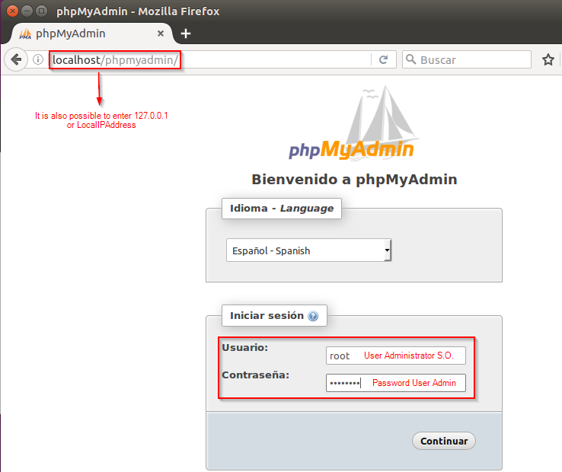

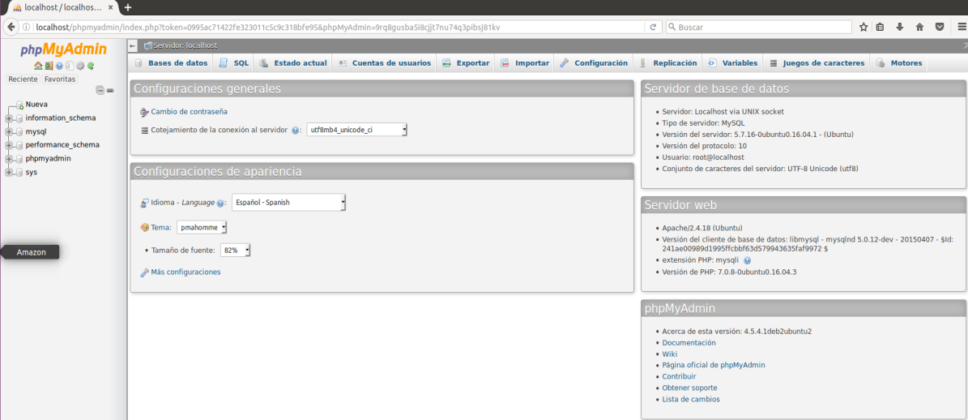

Finally we will check the versions of the software installed including the S.O:

**System version**:

*We open a terminal and write the following sentence:*

***$ cat /etc/issue***

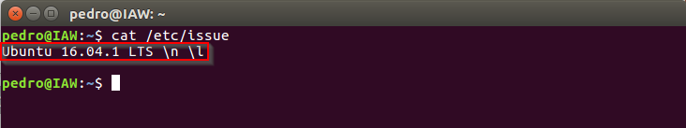

**Apache version:**

*We open a terminal and write the following sentence:*

***$ apache2ctl -v***

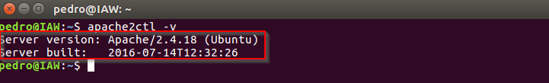

**MySQL version:**

*We open a terminal and write the following sentence:*

***$ mysqladmin -u root -p version***

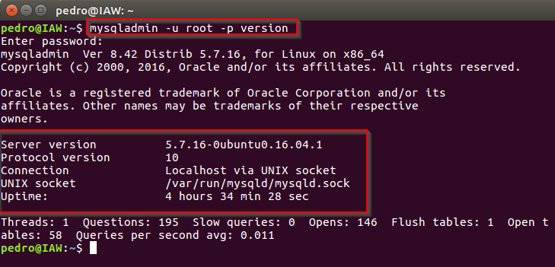

**PHP version:**

*We open a terminal and write the following sentence:*

***$ php -v***

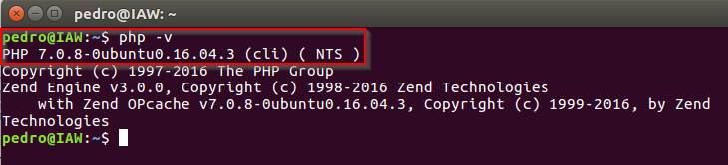

**phpMyAdmin version:**

